# RPi Default Booting & Keyboard Layout

1. By default RPi3 boots into X-server mode. This takes more booting time. And in most cases you don’t use a display. So the first thing is to disable it. To do so, you need to attach a HDMI display to it and change configurations. You also need a USB keyboard for this step.
2. Open a “terminal” window (Ctrl+ESC, and choose from the “Accessories”)
3. Run “sudo raspi-config” in the terminal
4. Select “boot options”

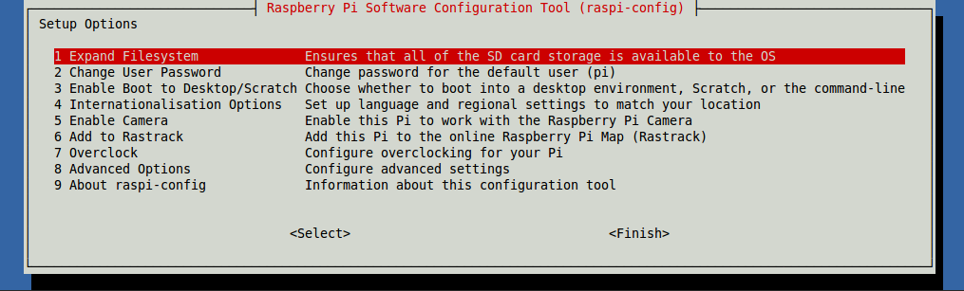

1. Select “B2 Console Autologin”

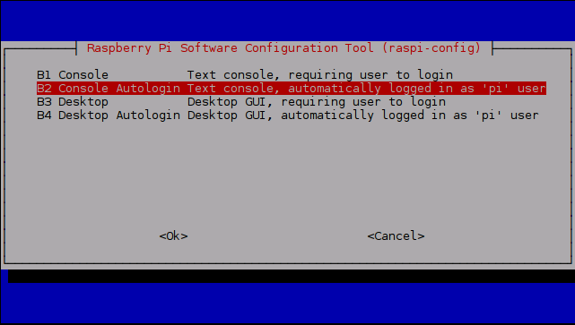

1. The newer version of Raspbian disables SSH by default, therefore you have to enable it. Navigate to and select “SSH”, Choose “Yes”, Select “Ok”
2. You can also change the keyboard to be “Finnish” in “4. Internationalisation Options”. It is better to do so because you need to input some symbols when editing configuration files.

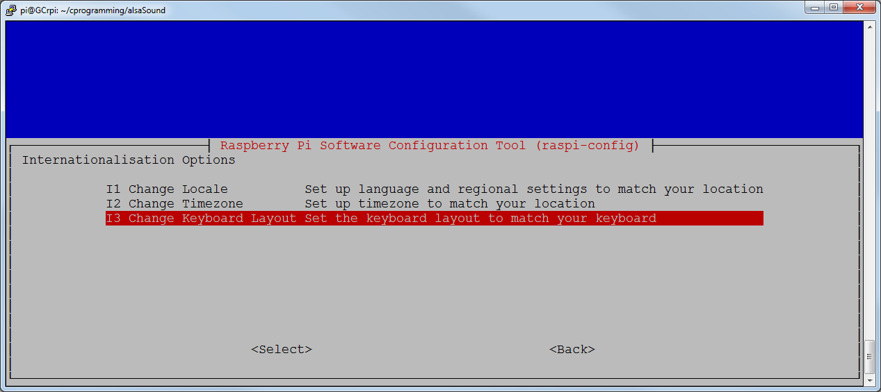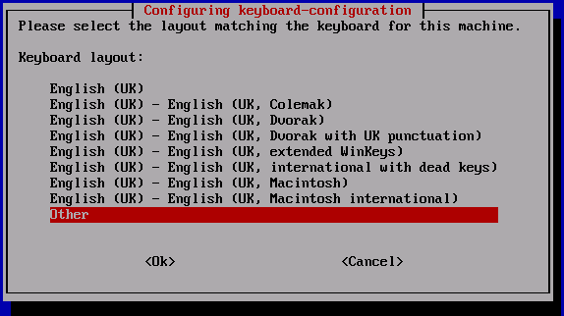

1. Reboot “sudo reboot”

# Send IP Address by Email

1. When using a Raspberry Pi remotely, you need to know its IP address so that you can connect to it. There are many ways to get the IP address from your Pi. The simplest way to edit “rc.local” file.
2. After the reboot, run command “sudo nano /etc/rc.local”
3. Add following lines:

#!/bin/sh -e

#

# rc.local

#

# This script is executed at the end of each multiuser runlevel.

# Make sure that the script will "exit 0" on success or any other

# value on error.

#

# In order to enable or disable this script just change the execution

# bits.

#

# By default this script does nothing.

# Print the IP address

sleep 30

_IP=$(hostname -I) || true

if [ "$_IP" ]; then

printf "My IP address is %s\n" "$_IP"

curl --url http://www.cc.puv.fi/~gc/php/sendMailRPi.php -d [email=gc@vamk.fi&from=gcPi3](mailto:email=gc@vamk.fi&from=gcPi3)

curl --url http://www.cc.puv.fi/~gc/php/rasp.php -d "ip=$_IP&name=gcPi3"

curl --url http://www.cc.puv.fi/~juma/raspi/rasp_ip.php -d "auth=mckdoe03&name=gcPi3&ip=$_IP"

fi

exit 0

1. The first line “sleep 30” is necessary to guarantee that IP address of Pi will be available.
2. The 1st “curl” command sends the IP address to your email box (**please change the address to your email**) using a PHP program made by [gc@vamk.fi](mailto:gc@vamk.fi).
3. The 2nd “curl” command sends IP address to my PHP page and you can see your device at <http://www.cc.puv.fi/~gc/php/rasp.php>.

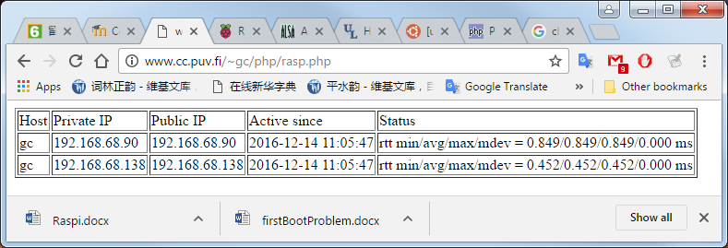

1. The 3rd “curl” command sends the IP address to Mr. Jukka Matila’s PHP page and you can see your device in his page: <http://www.cc.puv.fi/~juma/raspi/>.

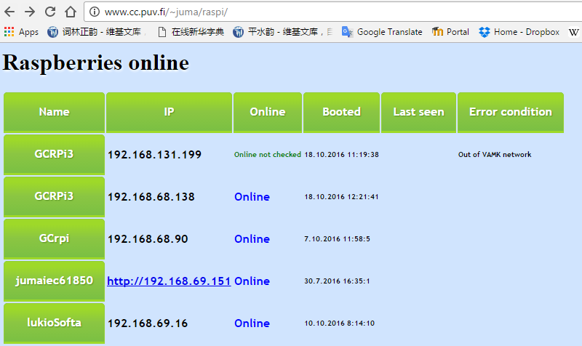

# Set USB Sound Card as Default

1. Boot up RPi, and apply the USB sound card.
2. RPi onboard sound card doesn’t have microphone interface. We have to change the default audio device to be USB sound card.
3. Use “lsusb” command to check if your USB sound card is mounted:

pi@raspberrypi:~ $ lsusb

Bus 001 Device 004: ID 0d8c:000c C-Media Electronics, Inc. Audio Adapter

Bus 001 Device 003: ID 0424:ec00 Standard Microsystems Corp. SMSC9512/9514 Fast Ethernet Adapter

Bus 001 Device 002: ID 0424:9514 Standard Microsystems Corp.

Bus 001 Device 001: ID 1d6b:0002 Linux Foundation 2.0 root hub

1. Use “sudo nano /etc/asound.conf”command and put following content to the file:

pcm.!default {

type plug

slave {

pcm "hw:1,0"

}

}

ctl.!default {

type hw

card 1

}

1. Go to your home directory. Use “nano .asoundrc” command and put the same content to the file.
2. Run “alsamixer” you should be able to see that USB sound card is the default audio device.

┌───────────────────────────────────────────── AlsaMixer v1.0.28 ──────────────────────────────────────────────┐

│ Card: C-Media USB Headphone Set F1: Help │

│ Chip: USB Mixer F2: System information │

│ View: F3:[Playback] F4: Capture F5: All F6: Select sound card │

│ Item: Headphone [dB gain: -20.13, -20.13] Esc: Exit │

│ │

│ │

│ ┌──┐ ┌──┐ │

│ │ │ │ │ │

│ │ │ │ │ │

│ │ │ │ │ │

│ │ │ │ │ │

│ │ │ │ │ │

│ │ │ │ │ │

│ │ │ │▒▒│ │

│ │ │ │▒▒│ │

│ │ │ │▒▒│ │

│ │ │ │▒▒│ │

│ │ │ │▒▒│ │

│ │▒▒│ │▒▒│ │

│ │▒▒│ │▒▒│ │

│ ├──┤ ├──┤ ┌──┐ │

│ │OO│ │MM│ │OO│ │

│ └──┘ └──┘ └──┘ │

│ 19<>19 52 │

│ < Headphone > Mic Auto Gain Control │

│ │

│ │

└──────────────────────────────────────────────────────────────────────────────────────────────────────────────┘

# Fix the Bug of arecord

1. The newest version of Raspbian (a.k.a. Jessie) comes with a new version of alsa-utils (1.0.28), which has a bug while recording: it doesn’t stop even a ‘—duration' switch is given, and generates lots of useless audio files. To fix this problem, we have to downgrade alsa-util to an earlier version (1.0.25).
2. Use “sudo nano /etc/apt/sources.list” command and add the last line:

deb http://mirrordirector.raspbian.org/raspbian/ jessie main contrib non-free rpi

# Uncomment line below then 'apt-get update' to enable 'apt-get source'

#deb-src http://archive.raspbian.org/raspbian/ jessie main contrib non-free rpi

deb http://mirrordirector.raspbian.org/raspbian/ wheezy main contrib non-free rpi

1. Run “sudo apt-get update”
2. Run “sudo aptitude versions alsa-utils” to check if version 1.0.25 of alsa-util is available:

pi@raspberrypi:~ $ sudo aptitude versions alsa-utils

Package alsa-utils:

i 1.0.25-4 oldstable 500

p 1.0.28-1 stable 500

1. Run “sudo apt-get install alsa-utils=1.0.25-4” to downgrade.
2. Reboot (if necessary)
3. Run “arecord -r44100 -c1 -f S16_LE -d5 test.wav” to test that your microphone is working. You should see a “test.wav” file in the current folder.
4. Put earphone on. Run “aplay test.wav” to check that your recording is okay.

# Install libcurl

1. First use command “ls /usr/include/curl” to identify that /usr/include/curl/ folder exists or not.
2. If the folder doesn’t exist. Run “sudo apt-get update” to update the application list.
3. Run “sudo apt-get install libcurl3” to install the libcurl3.
4. Run “sudo apt-get install libcurl4-openssl-dev” to install the development API of libcurl4.